# C:\Users\ADMIN\Desktop\lo.PNG

Organ Farms is a web store that provides only organic food products to the customers. The products are directly bought from the farmers. Our farmers only use organic methods for farming. We assure 100% natural and organic food products from our Store.

Our motto is to encourage farmers who follow organic methods for cultivation. Basic advantages of organic food products are:

* **Organic produce contains no pesticides.**
* **Organic food is often fresher.**
* **Organic farming is good for the environment.**
* **Organically raised animals are NOT given antibiotics, growth hormones, or fed animal byproducts.**
* **Organic meat and milk are richer in certain nutrients.**
* **Organic food is GMO (**Genetically Modified Organisms) **–free.**

FARMING PROCESS

## Farming Practices & Methods

http://localhost:8080/orga/img/core-img/decor.png

* Rotating crops and embracing diversity...
* Planting cover crops...
* Reducing or eliminating tillage...
* Applying integrated pest management (IPM)...
* Integrating livestock and crops...
* Adopting agro forestry practices...
* Managing whole systems and landscapes.

Our webstore will provide healthy and natural products to the customers. We provide:

* Best Service



We provide the best services for the satisfaction of our customers and farmers. We always strive for their comfort. We provide the products with a reasonable price. We assure 24x7 services for the customers to get the Organic food Products and farmers to sell their goods.

##### Farm Experiences



We directly get through the work of our farmers and assist them to follow organic ways of cultivation. We check the 100% naturality of the product and we certify them to work with us.

##### 100% Natural



We provide 100% natural products in our store for the customers. Our team will check the quality of the products for sustaining good health of our customers.

##### Farm Equipment



We provide the best equipments for the farmers for their cultivation for their needs. The equipment we provide is highly advanced which helps in less investment and to gain more profits.

* Organic food



We provide only organic food which was cultivated without using any chemical pesticides. Health of our customers is our only concern.

**Organic farming:**

Organic farming is an alternative agricultural system which originated early in the 20th century in reaction to rapidly changing farming practices. Organic farming continues to be developed by various organic agriculture organizations today.

It is defined by the use of fertilizers of organic origin such as compost manure, green manure, and bone meal and places emphasis on techniques such as crop rotation and companion planting. Biological pest control, mixed cropping and the fostering of insect predators are encouraged. In general, organic standards are designed to allow the use of naturally occurring substances while prohibiting or strictly limiting synthetic substances.

For instance, naturally occurring pesticides such as pyrethrin and rotenone are permitted, while synthetic fertilizers and pesticides are generally prohibited. Synthetic substances that are allowed include, for example, copper sulfate, elemental sulfur and Ivermectin. Genetically modified organisms, nanomaterials, human sewage sludge, plant growth regulators, hormones, and antibiotic use in livestock husbandry are prohibited. Reasons for advocation of organic farming include advantages in sustainability, openness, self-sufficiency, autonomy/independence, health, food security, and food safety.

Organic agricultural methods are internationally regulated and legally enforced by many nations, based in large part on the standards set by the International Federation of Organic Agriculture Movements (IFOAM), an international umbrella organization for organic farming organizations established in 1972.

MAKE THE GREEN WORLD

## Farming Practices to Save Nature

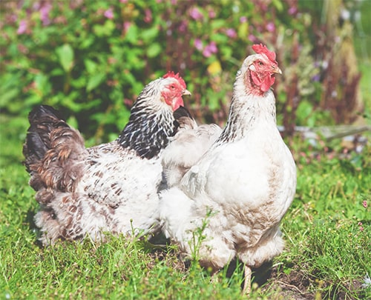 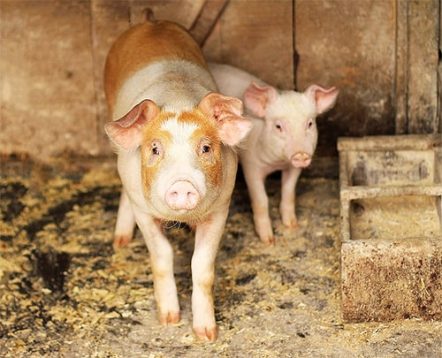 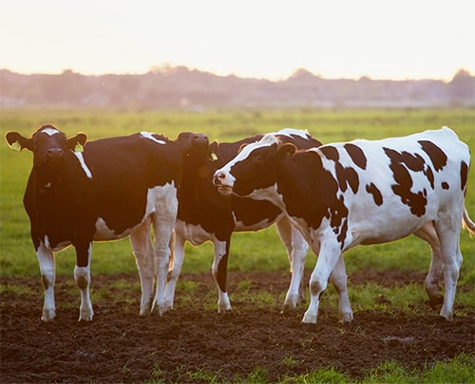

#### Chicken Farmed For Meat

#### Chickens have a lifespan of six years or more. Under intensive farming methods in the US, a chicken raised for meat will live for approximately six weeks before slaughter...

#### .Pig Farm Management:

Pig farming is the raising and breeding of domestic pigs as livestock, and is a branch of animal husbandry. Pigs are farmed principally for food (e.g. pork, bacon, gammon) or sometimes skinned....

#### Beef Cattle Farming

Beef cattle are cattle raised for meat production (as distinguished from dairy cattle, used for milk production). The meat of mature or almost mature cattle is mostly known as beef...

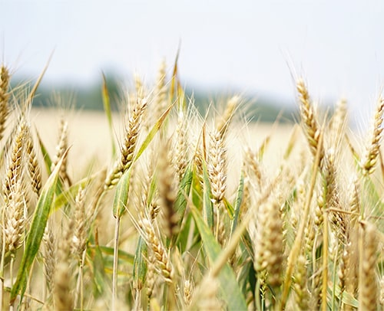  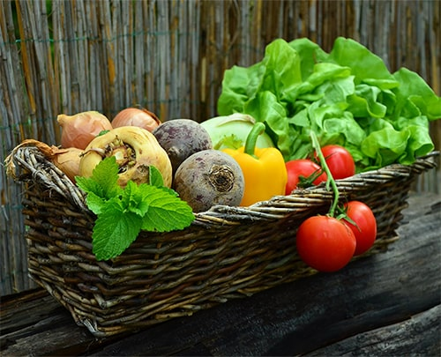

#### Improved Rice Cultivation

Rice is the staple food of 3 billion people, providing one-fifth of calories consumed worldwide. Its cultivation is responsible for at least 10 percent of agricultural greenhouse gas emissions and 9 to 19 percent of global methane emissions

#### Soil Improvement Techniques

Soil fertility is the ability of soil to sustain plant growth and optimize crop yield. This can be enhanced through organic and inorganic fertilizers to the soil. Nuclear techniques provide data that enhances soil fertility and crop production while minimizing the environmental impact....

#### Intensive Fruit Farming

The subject of fruit and nut production deals with intensive culture of perennial plants, the fruits of which have economic significance (a nut is a fruit, botanically)....

FARM PRODUCE

## The Future of Agriculture

http://localhost:8080/orga/img/core-img/decor.png

The World Government Summit launched a report called Agriculture 4.0 – The Future Of Farming Technology, in collaboration with Oliver Wyman for the 2018 edition of the international event. The report addresses the four main developments placing pressure on agriculture to meeting the demands of the future: Demographics, Scarcity of natural resources, Climate change, and Food waste The report states that, although demand is continuously growing, by 2050 we will need to produce 70 percent more food. Meanwhile, agriculture’s share of global GDP has shrunk to just 3 percent, one-third its contribution just decades ago. Roughly 800 million people worldwide suffer from hunger. And under a business-as-usual scenario, 8 percent of the world’s population (or 650 million) will still be undernourished by 2030. The reality is that very little innovation has taken place in the industry of late—in any case, nothing to indicate that food scarcity and hunger will not be an issue in the coming decades...

**Registrations:**

Users can register themselves as a Farmer or a Buyer. In the registration form customers have to give their details like First name, Last name, Aadhaar no, Email Id, User name ,Password, and customer has to select one type in he/she has to register for the orga farms. Once customer has completed the registration process he/she will get a Mail from us.

**LOGINS:**

Once the customer has successfully registered to our orga farms, he/she can able to login to the site to get best services from us. Here type in which they have being logged in depends upon the type they registered while registration.

After login successfully they will be redirected to specified dashboard base on their type.

* If any farmer gets logged in, their dashboard looks like:

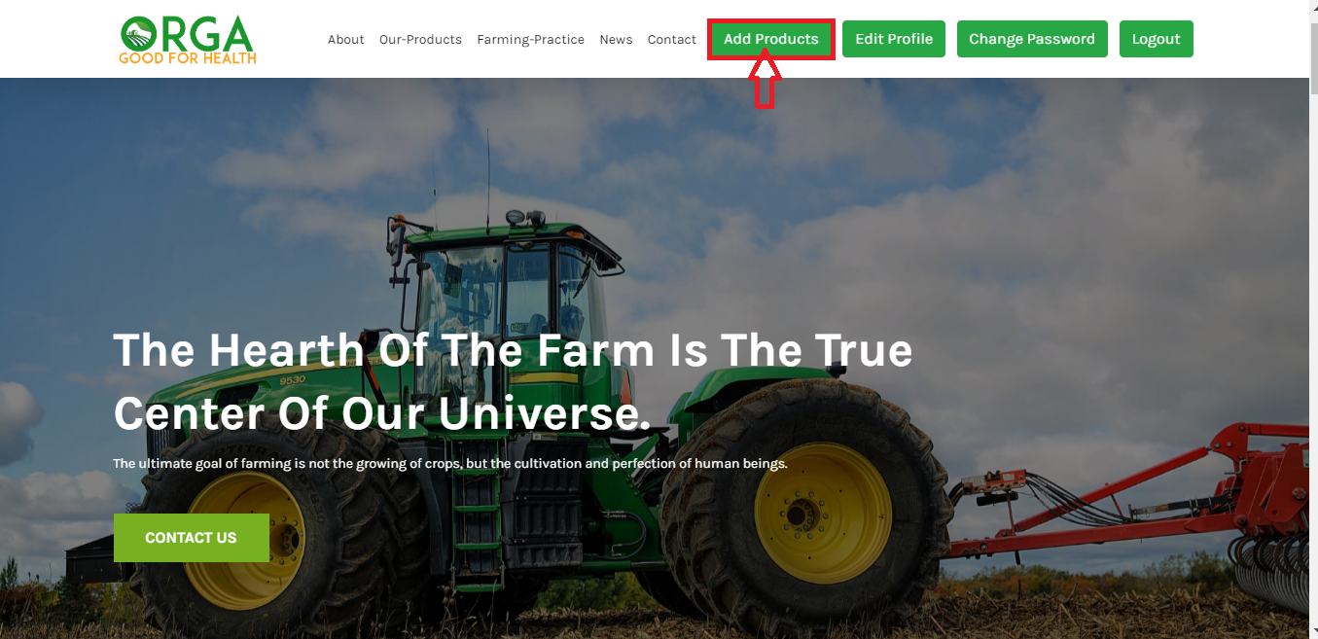

The farmers have the chance to add their products to our store. Farmers who are interested to add products can add their products by clicking on the Add Products button on the menu bar.

When the button is clicked then a form get displayed as:

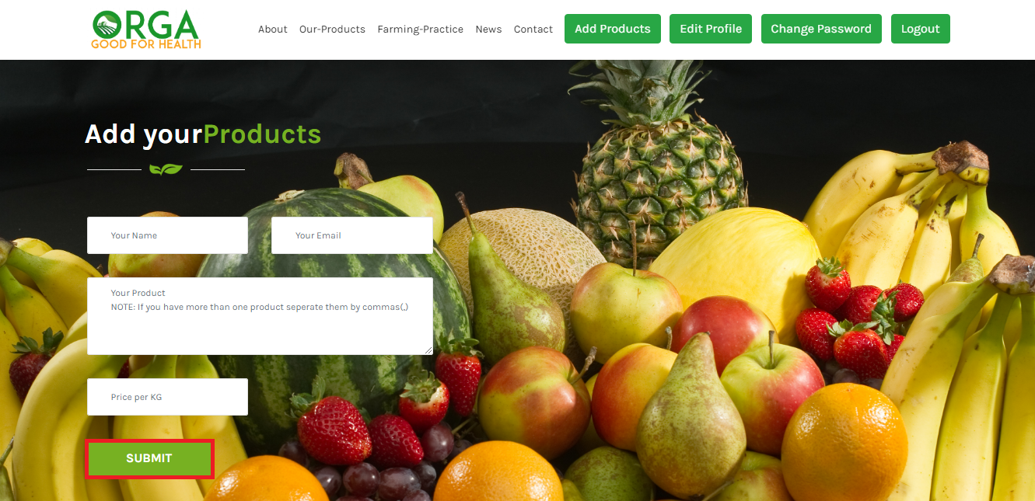

Once the farmer submits their product details, then our admin will receive and verify the request of farmers. If possible our admins will add the products to our store.

* If any Buyer gets logged in, then store will be displayed:

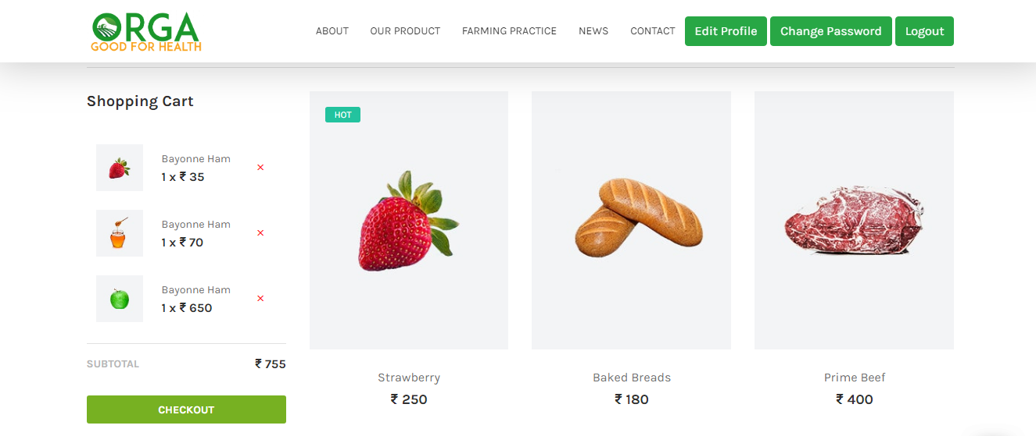Our store contains wide range of products. We provide best graded products. Some of the types are:

* Vegetables
* Fruits
* Grains
* Nuts & dry fruits
* Meat
* Spices & many more…..

Now buyers can buy their products by clicking on the product. Buyers have to specify the quantity before checking out the final subtotal.

**NOTE:** Both farmers and buyers can edit their profile and they can change their password if needed by just clicking on the buttons in the menu bar



We also consider the users feedbacks and reviews on our services:

